POTENTIAL GOVERNOR STATEMENT OF INTEREST
Title: ...................... Name:
Address:
..................................................................................................... Postcode:
Tel No: ............................................. Mobile:
Email:
Current or last position:
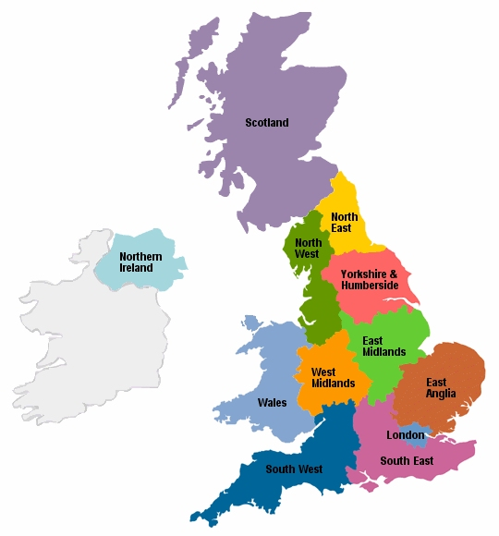
Which area(s) would you consider? Please tick all that apply and be as specific as you like:
5
9
7
3
2
6
8
□ 1 London □ 7 Yorkshire
□ 2 South East □ 8 East Midlands
□ 3 South West □ 9 East Anglia
□ 4 West Midlands □ Ireland
□ 5 North West □ Wales
□ 6 North East □ Scotland

4
Statement of interest, areas of expertise and experience:

AGBIS will assume that you have consented to the forwarding of these details to schools which ask to have them.
Signed: ......................................................................... Date:
Please return this form with a brief CV to enquiries@agbis.org.uk
or by post to 3 Codicote Road, Welwyn, Herts AL6 9LY

